Project Report Template
Title of Project: CareShare Donation & Volunteer App for Orphanages.
Name of the Innovator: Prajwal Gajendra Naik
Start Date: 27-10-2025
End Date: 31-10-2025

Day 1: Empathise & Define
Step 1: Understanding the Need
- Which problem am I trying to solve?
Iam trying to solve the problem where people who want to help (by donating or volunteering) don’t have an easy, trustworthy way to find and support orphanages, and orphanages struggle to reach and manage supporters effectively. Hence my app CareShare solves this by creating one platform that makes donating and volunteering simple, transparent, and impactful.
- Who is affected by this problem?
- How did I find out about this? [Select whichever is applicable]
- Interviews
- Observation
- Online Research
- AI Tools
Step 2: What is the problem?
The problem is that many orphanages lack proper visibility and access to consistent donations or volunteers because there is no single, reliable platform that connects them with people who want to help.
Why is this problem important to solve?
Many orphanages struggle to get consistent help because there’s no trusted platform connecting them with donors and volunteers. This leads to unmet needs for children and wasted goodwill from people who want to help Solving this problem creates a transparent way to connect hearts with those in need.
Take-home task
Ask 2-3 people what they think about the project:
- 1. Student (Rural College Student):
“I think CareShare is a great idea! It gives young people like us an easy way to volunteer or donate, even with small contributions. It makes helping others simple and meaningful.”
- 2. Teacher (Career Guidance Teacher):
“This project has real social value. It teaches empathy, responsibility, and community service. I like that it connects technology with humanity — a great example of using innovation for a good cause.”
- 3. Parent (From a Rural Area):
“I appreciate this idea because it makes it safer and more transparent to help orphanages. As a parent, I’d want my children to use an app like this to learn the importance of giving and kindness.”
AI Tools you can use for Step 1 and 2:
AI Tools Used:
1. Meta MGX
- Used to generate creative media content such as posters, visual concepts, and awareness graphics and Used for app design and layout.
- Helped in enhancing design ideas by suggesting layouts, color schemes, and emotional imagery related to children and Created AI-based interface mockups.
- Assisted in visual storytelling, making the awareness message more impactful through AI-driven design support and Helped visualize user flow.
2. ChatGPT
- Used to research and write content for posters, app prompts, and awareness messages in clear, empathetic language and Generated project ideas and content.
- Wrote problem and solution statements.
- Assisted in idea generation and report writing, saving time and improving the overall quality
Helped structure the app concept.
3.Web Application Reference
- Studied similar donation apps Used to research and understand existing donation and volunteering platforms.
- Took ideas for UI and features to design better user experience and functionality.
- Improved app usability and design.
Day 2: Ideate
Step 3: Brainstorming solutions
- List at least 5 different solutions (wild or realistic):
- Adopt an Orphanage Feature – Let users “adopt” an orphanage to provide monthly support or mentorship.

- Impact Tracker – Show real-time updates of how donations and volunteer efforts are making a difference.

- Gamified Volunteering – Add badges, levels, and leaderboards to encourage consistent participation.

- Wish List System – Allow orphanages to post specific needs (like books, clothes, or toys) that donors can directly fulfill.

- AI Donation Matchmaker – Use AI to suggest nearby orphanages or causes based on the user’s interests and donation history.
Step 4: My favourite solution:
My favourite solution is the “Wish List System.” It allows each orphanage to post their specific needs like books, clothes, food, or school supplies — and donors can directly choose what to contribute. This makes donations more personal, transparent, and impactful, ensuring that every item given is something the orphanage truly needs.

Step 5: Why am I choosing this solution?
I chose the Wish List System because it makes the donation process clear, meaningful, and need-based. It helps donors know exactly where their help is going and ensures orphanages receive what they truly need, reducing waste and increasing trust between donors and organizations.
AI Tools you can use for Step 3-5:
AI Tools for Step 3–5
1. Meta MGX
- Generated app interface and screen designs for overall app experience
- Customized layouts for home, donate, and volunteer pages.
- Previewed and refined the final app look using AI suggestions.
2. ChatGPT
- Created project idea, problem, and solution statements.
- Generated content for app features and descriptions.
- Helped brainstorm and organize the app’s overall structure to access it efficiently.
3. Web application Reference
- GoFundMe – for understanding donation transparency and campaign tracking
- GiveIndia – for structured charity listings and verified NGO partnerships.
- VolunteerMatch – for discovering volunteering opportunities and event organization.
AI Tools you can use for the take-home task:
Canva AI / Adobe Firefly-Assisted in designing digital posters and infographics with AI-generated templates.
ChatGPT (by OpenAI)-Helped in writing and organizing content for the overall App appearance.
Day 3: Prototype & Test
Step 6: Prototype – Building my first version
What will my solution look like?
- Home Screen: Header Section App name “CareShare” with a warm welcome message.
- Quick Access Buttons (Main Menu Grid)- “Donate,” “Volunteer,” and “Find Orphanages” for instant access.
- Banner/Carousel: Highlights donation drives, success stories, or featured orphanages.
- Interactive Section (Optional but Engaging- Shows a list or map view of nearby verified orphanages.
- Wish List Section: Displays current needs (books, food, clothes, etc.) from orphanages.
Design Style:
- Simple, intuitive, and easy to navigate for Everyone.
- Bright and engaging visuals to make guidance and access.
- Mobile-friendly layout for easy access on smartphones.
Prototype Tools:
- Built using Meta MGX, no coding required, with all features interactive and testable.
What AI tools will I need to build this?
AI Tools Needed to Build are:
- Meta MGX
  - No-code platform to design and deploy the app.
  - Allows building interactive screens, user interfaces, and motivational quotes
- ChatGPT (or similar LLMs)
  - To generate content, conversation flows, and User friendly responses.
  - Can help personalize recommendations for users based on their profile and problems.
- AI Chatbot Design References
  - Google Dialogflow / IBM Watson Assistant / Microsoft Bot Framework
  - To structure conversation logic and handle user queries effectively.
- AI Recommendation Tools (Optional but useful)
  - For matching people with their problems and to assist them with solutions and actions
  - Could use different location provided platforms

What AI tools I finally selected to build this solution?
- Chat GPT
- Metamgx

Tool Link: https://mgx-jajgkl5hk8e.mgx.world/

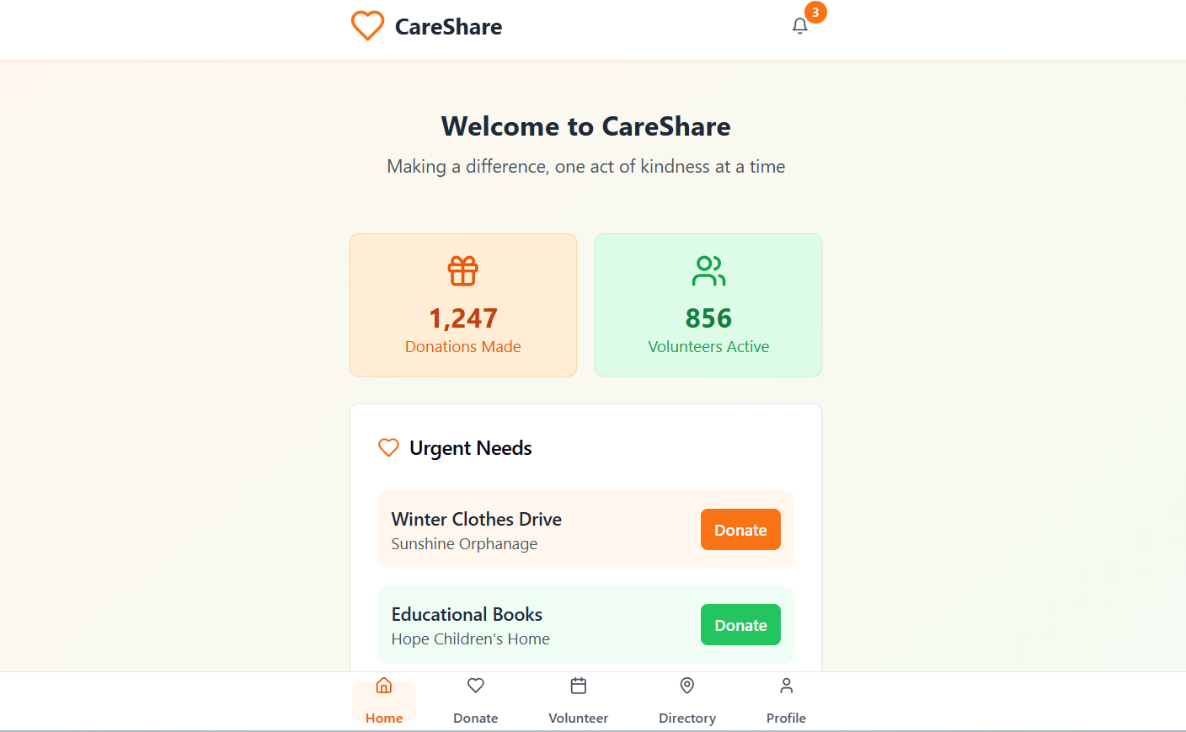

Internal Working of tool:
Profile Creation:
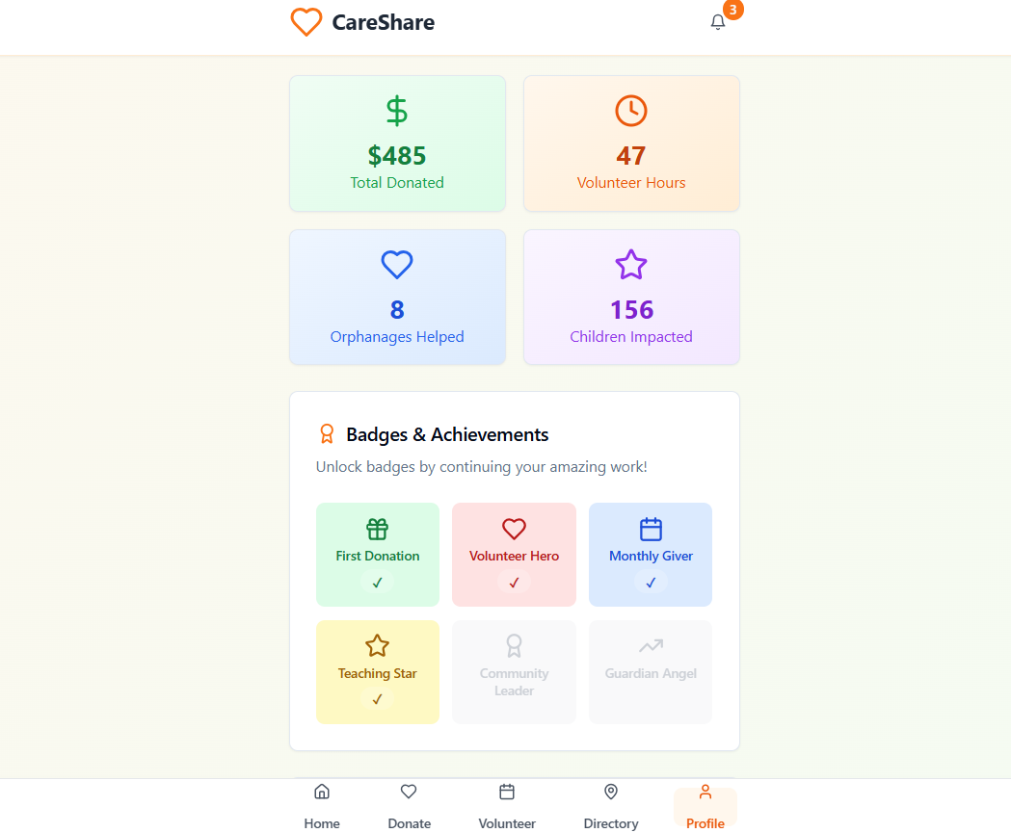

Tailoring recommendations for Volunteering sessions

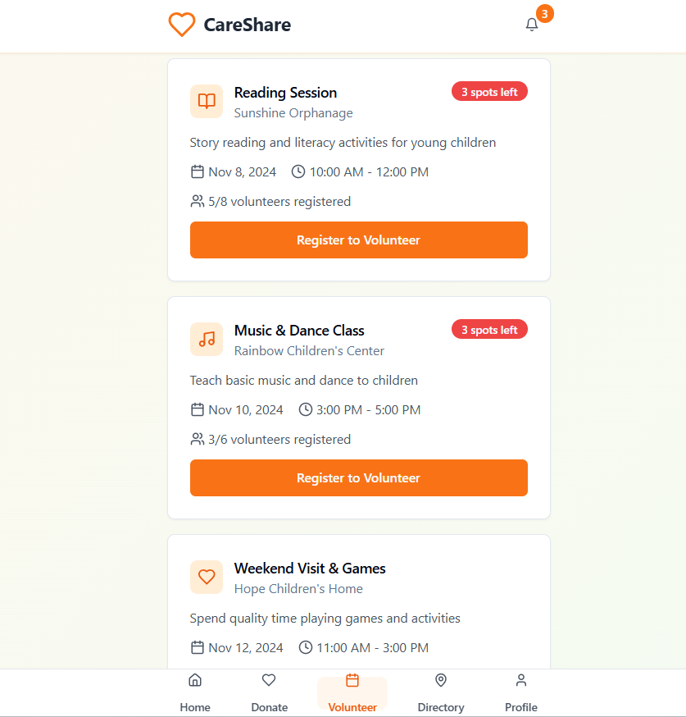

Location and directory based on locations:
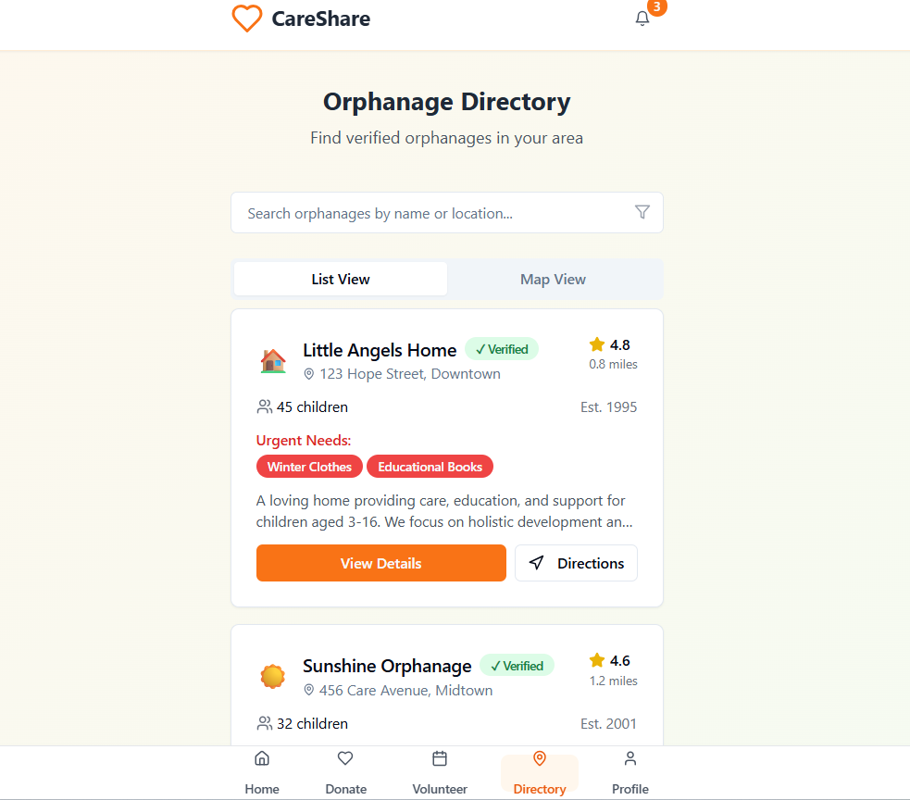

Resources and helpline based on profile:
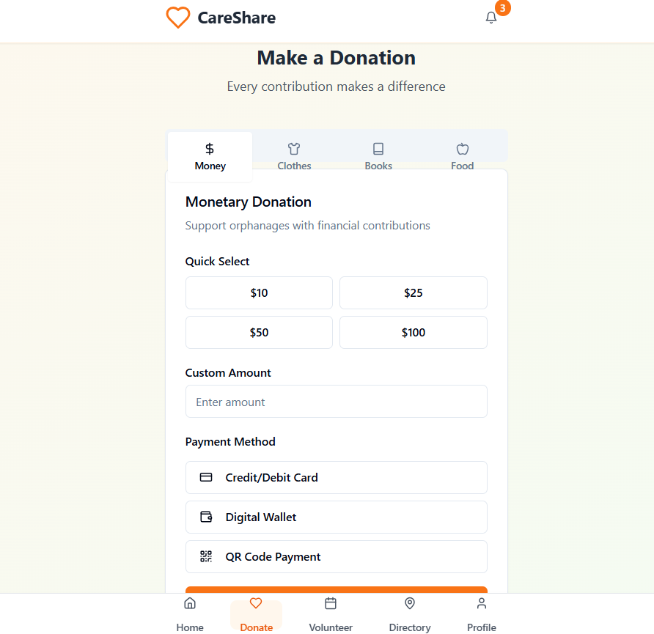

Step 7: Test – Getting Feedback
- Who did I share my solution with?
I shared my Care share Donation and Volunteer App For Orphanages solution with:
- Students from rural areas – to get feedback on usability and to get feedback from a user’s perspective.
- Teachers and career guidance counselors – to understand how well it supports and to understand the educational and social value of the project.
- Parents of rural students – 3. to know how families view the safety and trust of the app.
- Peers and mentors – for suggestions on improving features and design.
What feedback did I receive?
Feedback: Pros and Cons
Pros (Positive Insights from Feedback):
- Bridges the gap between donors, volunteers, and orphanages.

- Increases transparency in donations and volunteering activities.

- Encourages social responsibility and community participation.
Cons (Areas to Improve Noted in Feedback):
- Requires regular updates to keep orphanage data accurate.
- Needs strong security to protect donation and user information.
- Dependence on internet access, which may limit use in rural areas.
My Response for The Feedback:
The feedback I received was very helpful and positive. It made me realize that my app idea can truly make a difference by connecting people with orphanages easily and safely. I plan to include features like verified profiles, secure donations, and real impact updates to build more trust and confidence among users. Overall, the feedback encouraged me to improve and develop Care Share into a more reliable and meaningful platform.
👍 What works well:
What Works Well
- Lifetime Access: Users can access orphanage listings, donation options, and volunteer activities anytime without restrictions.
- No-Code Development: Built using Meta MGX, making it easy to update, manage, and expand the app without complex coding.
- Personalized Guidance: AI tools like ChatGPT help users find suitable donation or volunteering opportunities.
- Skill Building: Interactive features encourage users to develop empathy, responsibility, and communication skills.
- Location-Based Suggestions: The app recommends nearby orphanages and events for quick, effective participation.
- Mobile-Friendly and Intuitive: Works smoothly on all devices, ensuring easy access even in rural areas.

🔧 What needs improvement:
- Chatbot Responses: The AI chatbot can be improved to give more personalized guidance and emotional support to users.
- Interactive Features: The app could include more engaging options like live donation tracking, photos, and event updates.
- Resource Integration: 3. Needs expansion by adding verified NGOs and orphanages for better reach and credibility.
- Collaborations Needed: Can be strengthened by partnering with real organizations and local communities.
- User Experience Enhancements: The interface can be made smoother, more child-friendly, and available in multiple languages for better accessibility.

AI Tools you can use for Step 6-7:
ChatGPT/Perplexity AI/Claude AI/Canva AI/Chatling AI/Figma AI/Metamgx/Gamma AI: You can use these tools to build solutions/modelsand develop an app for an easy access.

Day 4: Showcase
Step 8: Presenting my Innovation:
I am presenting my innovation called CareShare — a digital app designed to connect donors, volunteers, and orphanages on one trusted platform.
It Features:
It aims to educate, protect, and make donating and volunteering simple, transparent, and accessible for everyone.
- Purpose: To connect donors, volunteers, and orphanages through one trusted digital platform.
- Goal: To make donating and volunteering easy, transparent, and accessible for everyone.
- AI Integration: Uses AI tools like ChatGPT for personalized guidance and smart recommendations.
- Features: Includes donation tracking, orphanage listings, volunteer registration, and wish-list requests.

Impact: The CareShare App creates a strong impact by connecting donors, volunteers, and orphanages on one trusted platform.It helps provide consistent support and resources to orphaned children while ensuring transparency in every contribution

<SHOWCASE YOUR INNOVATION TO YOUR PEERS>

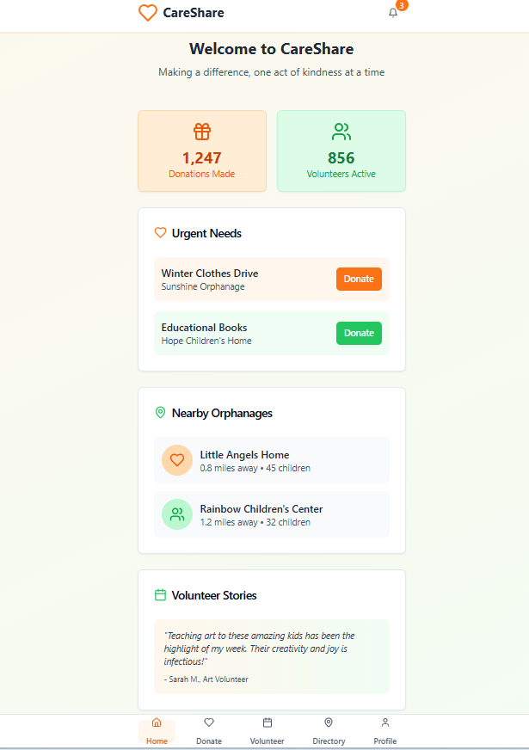

Step 9: Reflections
- What did I enjoy the most during this project-based learning activity?
I enjoyed the most learning how to use AI tools like Meta MGX and ChatGPT to bring my ideas to life. It was exciting to design an app that can truly help people and make a difference in society. I also loved exploring creative features, like donation tracking and volunteer connections, which made the project both meaningful and fun.

- What was my biggest challenge during this project-based learning activity?
My biggest challenge during this project was organizing all the ideas and turning them into a practical app design. It was difficult to balance creativity with real-world needs, especially while deciding which features to include. Understanding how to make the app user-friendly and secure also took time, but it helped me learn valuable problem-solving skills.
Take-https:
https://github.com/Prajwal6363882954/Care-share-
AI Tools you can use for Step 8:
Canva AI: You can use this to design your pitch document. Download your pitch document as a PDF file and upload on GitHub

